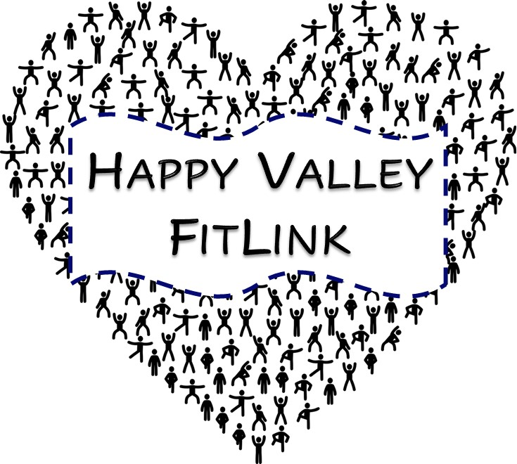
HAPPY VALLEY FITLINK

WELLNESS MANUAL
2020

TABLE OF CONTENTS

Overview of Physical Activity.…………………………………………1

Recipe For a Workout………………………………………………….2

Dimensions of Wellness……………………………………………….3

Nutrition………………………………………………………………….4

High Intensity Interval Training………………………………………..5

CrossFit………………………………………………………………….6

Yoga……………………………………………………………………...7

Ladder Workout………………………………………………………...8

At Home Scavenger Hunt……………………………………………..9

Exercise Card Game………………………………………………….10

Fit Dice Game………………………………………………………….11

Spell It Out……………………………………………………………..12

Things To Use In Your House For a Workout………………………13

Build Your Own Workout……………………………………………..14

Muscle Anatomy………………………………………………………15

Healthy Recipes……………………………………………………….16

Places To Be Active in State College, PA…………………………..20

OVERVIEW OF PHYSICAL ACTIVITY

What is physical activity?
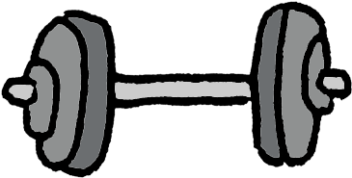
Physical activity is any type of movement that gets your muscles or your heart moving.

Why is physical activity important?
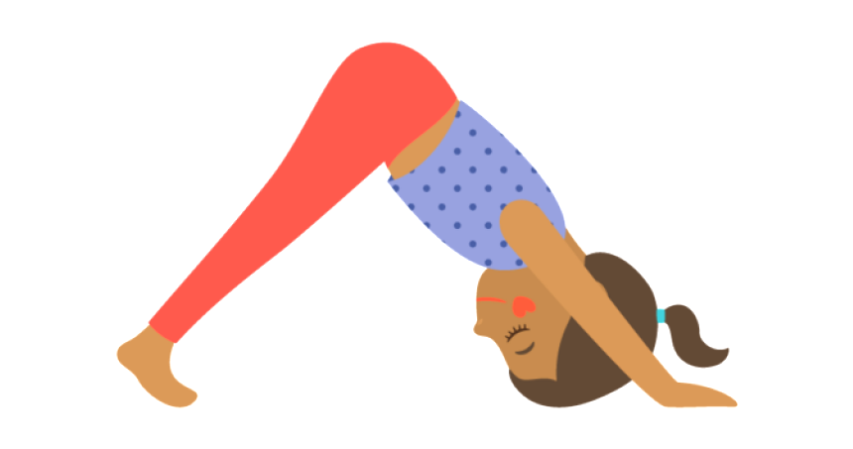
Physical activity is important because it can improve your health by reducing the risk of disease. Being physically active also has lots of benefits such as improving your quality of life and improving brain functioning.

Ways to stay active:
- Walking
- Biking
- Yoga and stretching
- Dancing
- Cardio drumming
- Kickboxing
- Playing a sport

How long and how often you should be participating in physical activity:
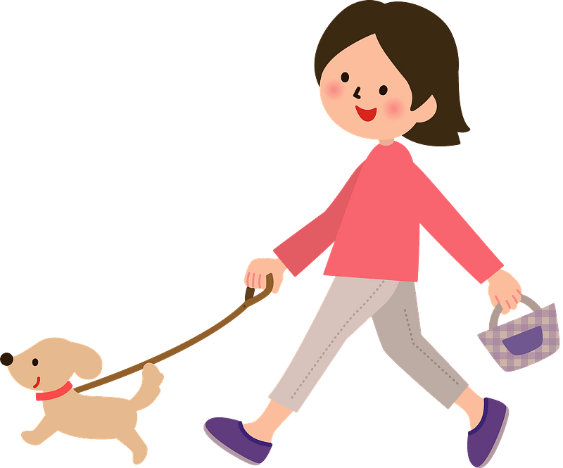
You should be getting at least 150 minutes of physical activity per week, and should be participating in muscle building activities at least 2 times per week.

RECIPE FOR A WORKOUT

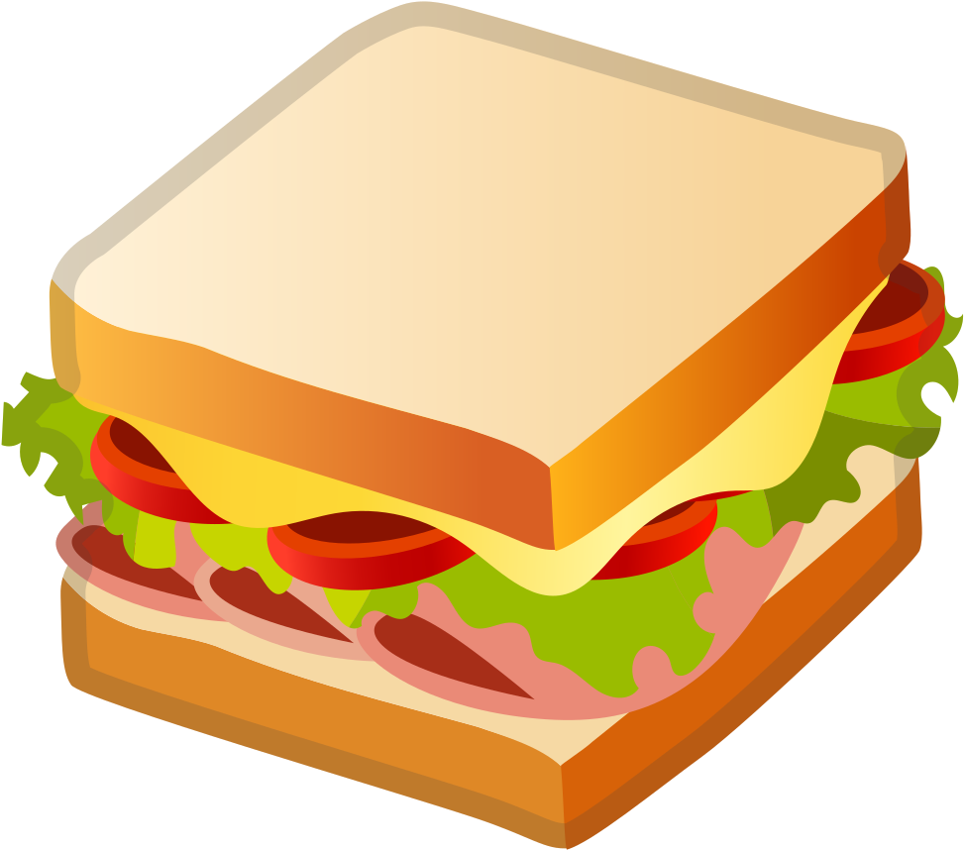
Think of designing your workout like how a sandwich is made! You must have all of the ingredients for the sandwich to be properly made and put together.

The structure of a workout - or the workout sandwich must contain many ingredients:
- A warm up - the first piece of bread
- The activity or workout - the meat or the middle of your sandwich
- A cool down - the last piece of bread

Ingredient #1: the first piece of bread - warm up
- A warm up must contain exercises to both get your heart beating fast as well as to get your muscles moving to prepare your body for movement
- About 5-10 minutes is enough time for a warm up

Ingredient #2: the meat or the middle of the sandwich - activity/workout
- The activity or workout is when yo should be working out your heart and other muscles
- Activities can include: yoga, jogging, dancing, swimming, basketball, CrossFit, HIIT, or an exercise ladder
- The middle should last anywhere between 30 minutes to 1 hour

Ingredient #3: the last piece of bread - cool down
- A cool down lowers your heart rate and body temperature back to normal levels
- Flexibility exercises to stretch your muscles should be included in the cool down
- About 5-10 minutes is enough time to cool down

DIMENSIONS OF WELLNESS - WELLNESS WHEEL
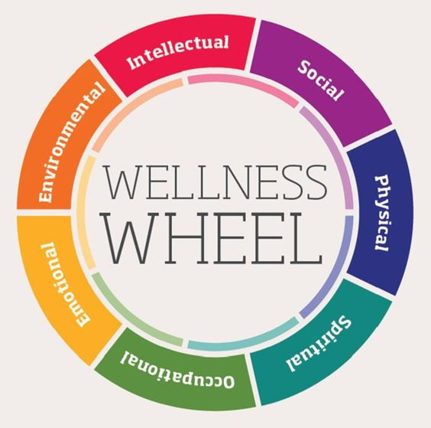

Intellectual: Learn new ideas, skills, and experience to open up your mind.
- Being creative, reading books, doing puzzles

Social: Make positive connections with friends, family, and new people.
- Being a good listener, being supportive

Physical: Keep your body moving and healthy with physical activity and exercise.
- Cleaning the house, participating in a sport, walking your dog

Spiritual: Create meaning and purpose in your life to keep your mind healthy.
- Practicing yoga, practicing religion

Occupational: Set goals and fulfillments from your job/career and as a student to make positive contributions.
- Seek motivating and interesting work

Emotional: Being able to handle your emotions such as happiness, sadness, and anger to allow you to grow as a healthy emotional person.
- Being optimistic and having a positive outlook, keeping a journal

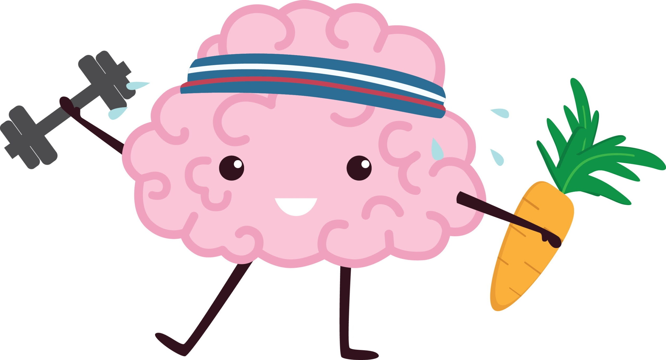
Environmental: Being able to understand the influence of the environment of which you live in, work in, and play in, protecting yourself from environmental hazards, and minimizing the negative impact of your behavior on the environment.
- Recycling, walking as a form of transportation

NUTRITION

Why is eating healthy important?
Eating healthy is an important part of living a healthy lifestyle. When combined with physical activity, eating a healthy diet can help you reach and maintain a healthy weight and helps you reduce the risk of diseases such as diabetes and heart disease.

What foods should you include in your diet?
Your diet should include a variety of fruits, vegetables, whole grains, lean meats or other sources of protein, and fat free or low fat dairy products. Examples of foods include:

Fruits - 1 to 2 cups per day
- Oranges
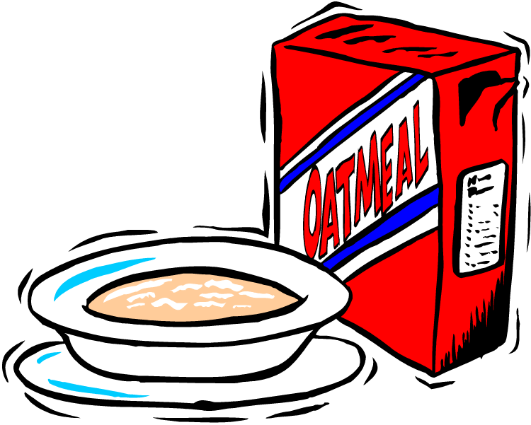
- Strawberries
- Bananas
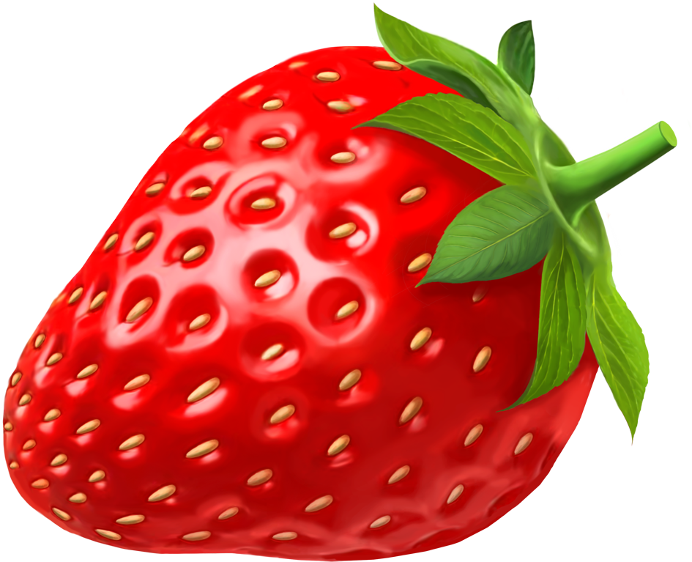
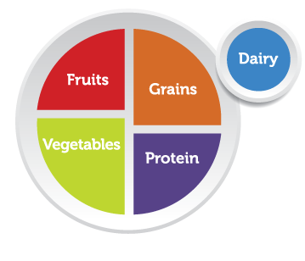
Vegetables - 1 to 3 cups per day
- Broccoli
- Carrots
- Peppers

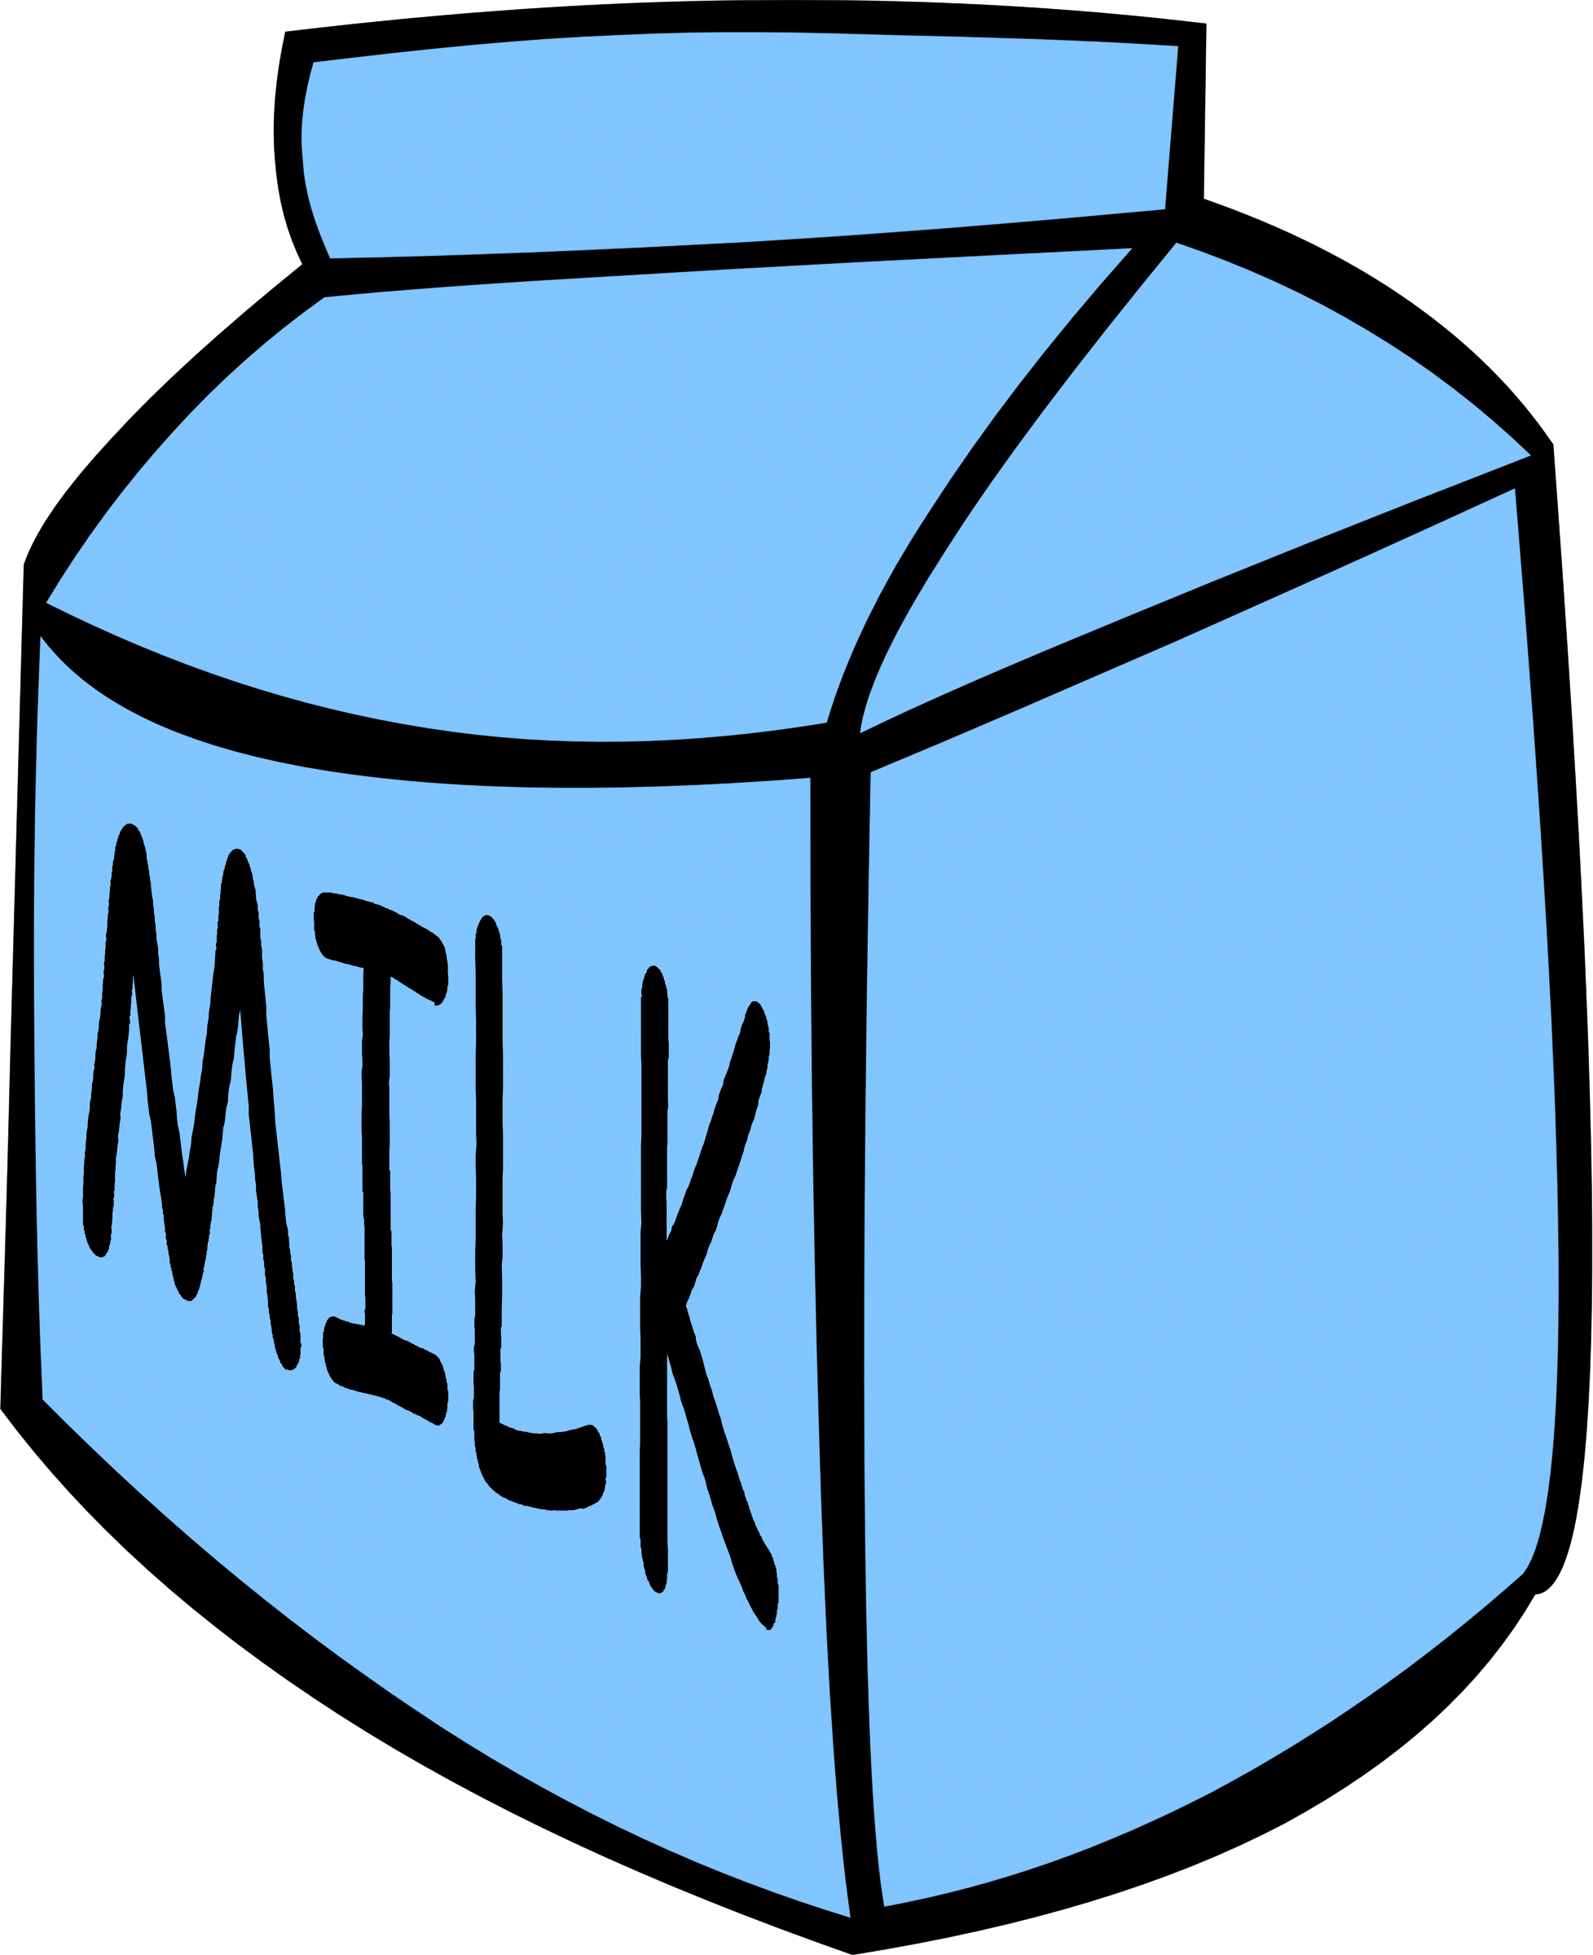
Grains - 3 to 8 ounces per day
- Oats/oatmeal
- Whole grain pasta
- Brown rice

Protein - 2 to 6.5 ounces per day
- Greek yogurt
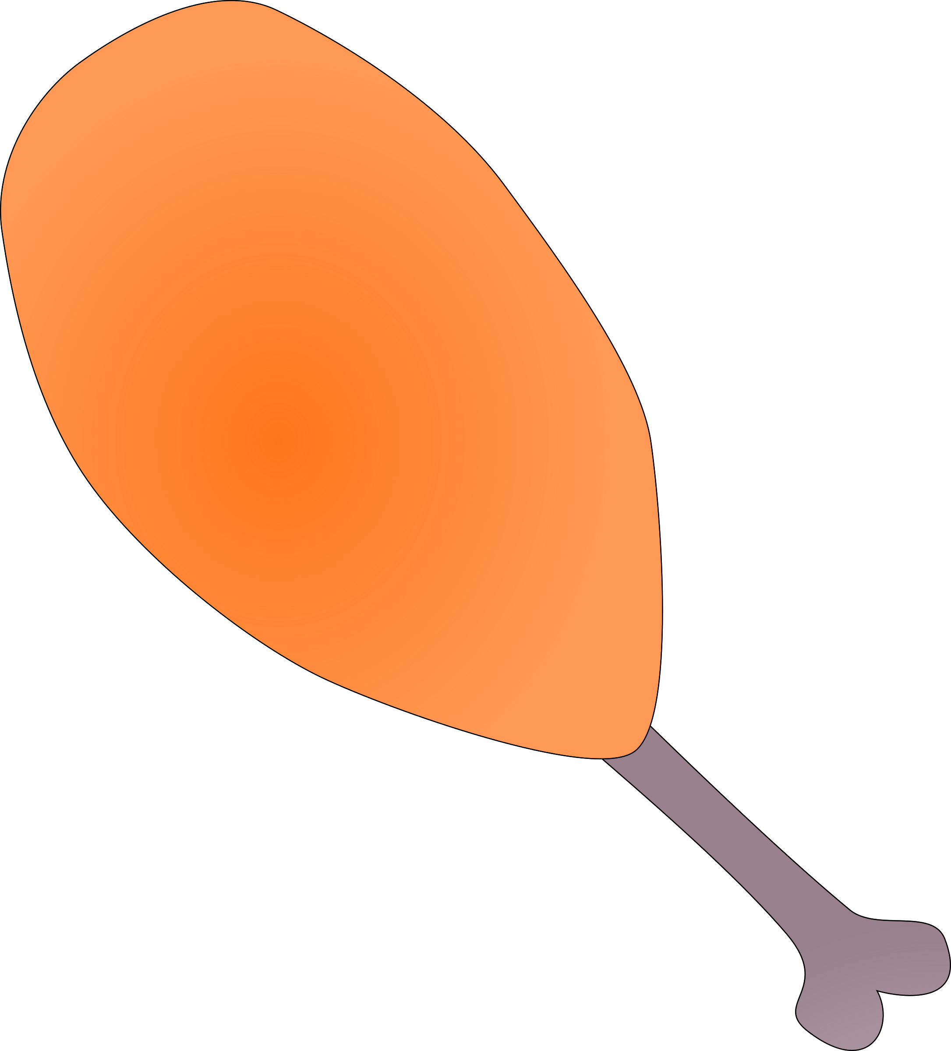
- Chicken breast
- Eggs

Dairy - 2 to 3 cups per day
- Cheese
- Yogurt
- Low fat milk

The food you are eating is fuel for your body!

HIGH INTENSITY INTERVAL TRAINING (HIIT)

What is HIIT?
- HIIT is a type of workout that combines a period od all-out exercise (working as hard as you can) followed by a short break
- HIIT workouts are a great way to work both your heart and other muscles at the same time

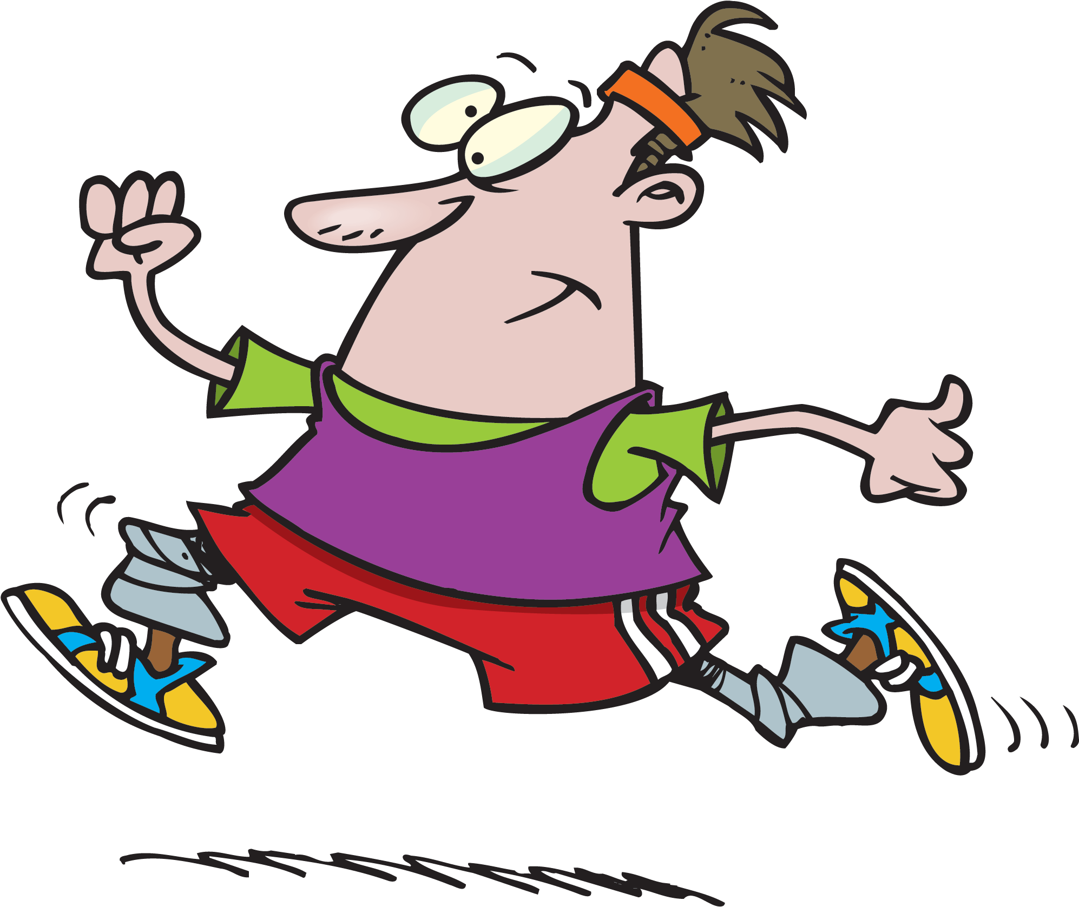
HIIT Workout:

Round 1:
- Push ups for 40 seconds
  - Rest for 20 seconds
- Crunches for 40 seconds
  - Rest for 20 seconds
- Hip bridges for 40 seconds
  - Rest for 20 seconds
- Jumping jacks for 40 seconds
  - Rest for 20 seconds
- Push up position shoulder taps for 40 seconds
  - Rest for 20 seconds

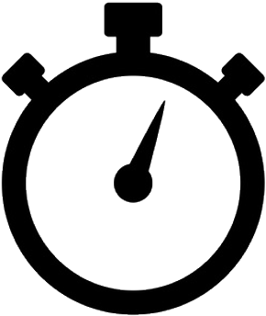

Round 2:
- Shoulder press for 40 seconds
  - Rest for 20 seconds
- Supermans for 40 seconds
  - Rest for 20 seconds
- Bicep curls for 40 seconds
  - Rest for 20 seconds
- Calf raises for 40 seconds
  - Rest for 20 seconds
- Lying leg raises for 40 seconds
  - Rest for 20 seconds
CROSSFIT

CrossFit is a type of workout for improving and building strength, agility, flexibility, and your cardiovascular fitness.

No Equipment CrossFit Workout:
- 2 crab walk across your yard or an open space
- 10 squat jumps
- 15 push ups
- 20 sit ups
- 3 sprints in your yard or an open space
- 20 shoulder presses
- 12 lunges (6 each side)
- 20 shoulder taps
- 15 supermans
- 10 calf raises
- 10 high knees in place
- 8 star jumps

* Write down the time it takes you to complete the workout, and then try to beat that time another day!

Time #1: _______________ Time #4: _______________

Time #2: _______________ Time #5: _______________

Time #3: _______________
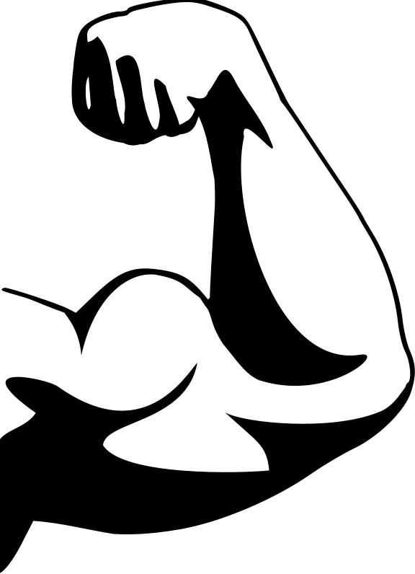

YOGA

What is Yoga?
The term “Yoga” is a Sanskrit word that means “union”. Yoga is a type of exercise that combines physical exercises, meditation, and breathing.

What is Yoga good for?
Yoga is a great way to work on strengthening the muscles, improving flexibility, and relieving stress.

Warrior III  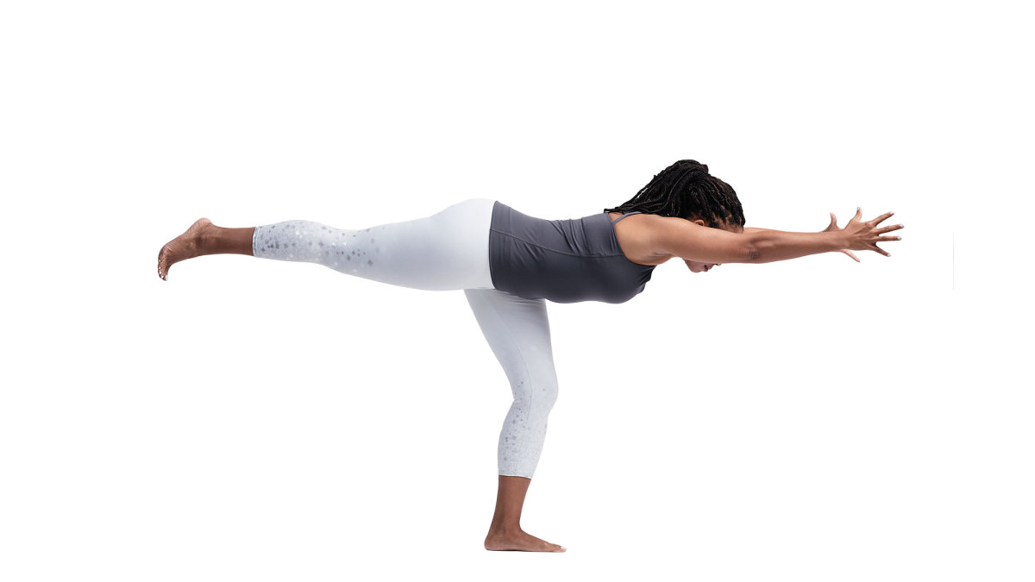 | Hero  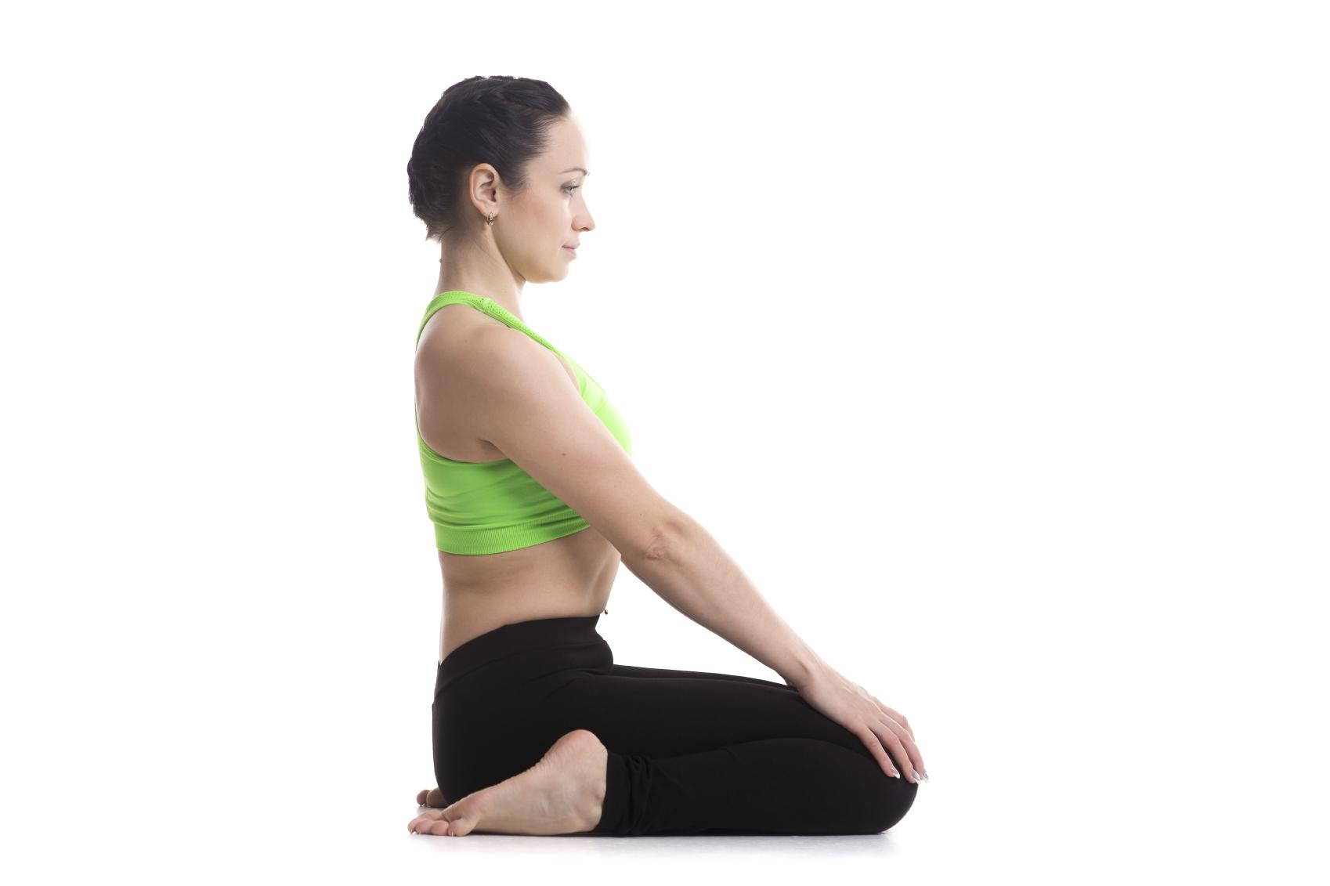 | Downward Facing Dog  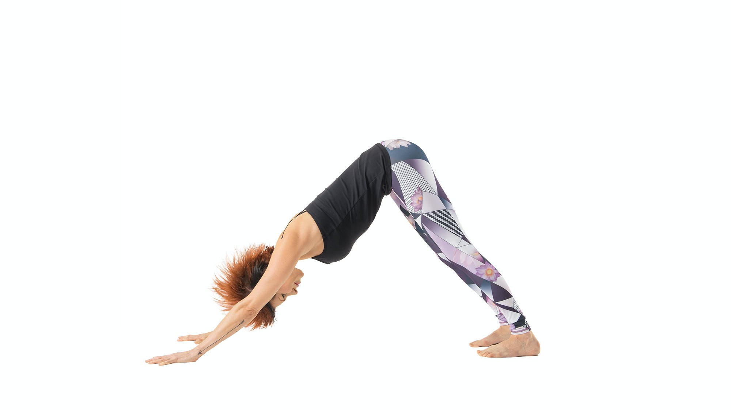
Triangle  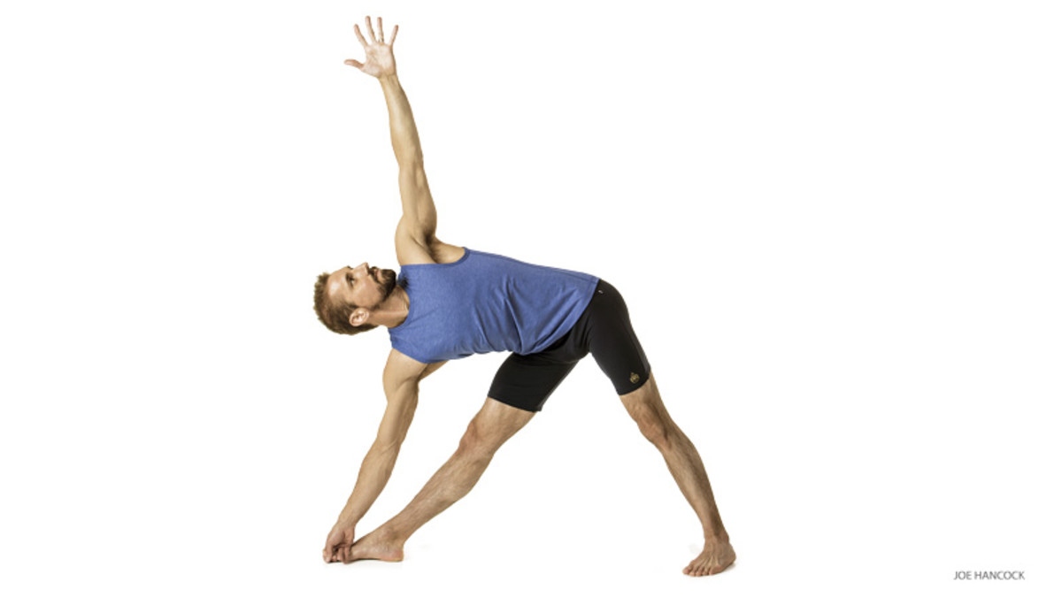 | Cat & Cow  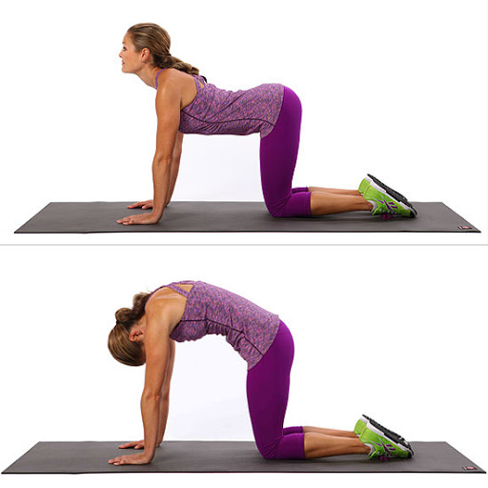 | Tree  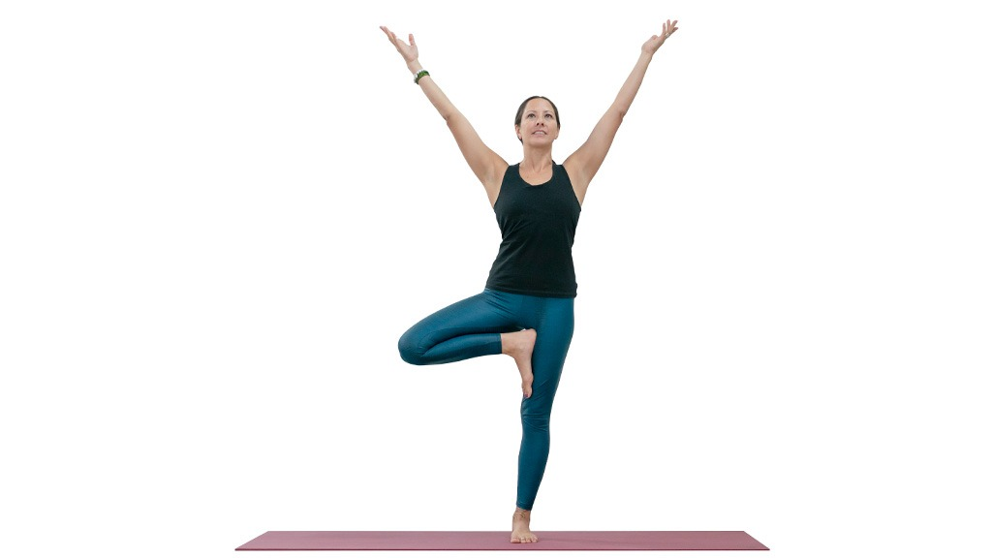

Other poses to try:

- Child pose | - Baby cobra | - Boat
- Locust | - Warrior II | - Savasana
EXERCISE LADDER

An exercise ladder is where you perform exercises for a certain amount of repetitions based on an ascending and/or descending pattern. Ladders are a great way to work on muscular endurance!
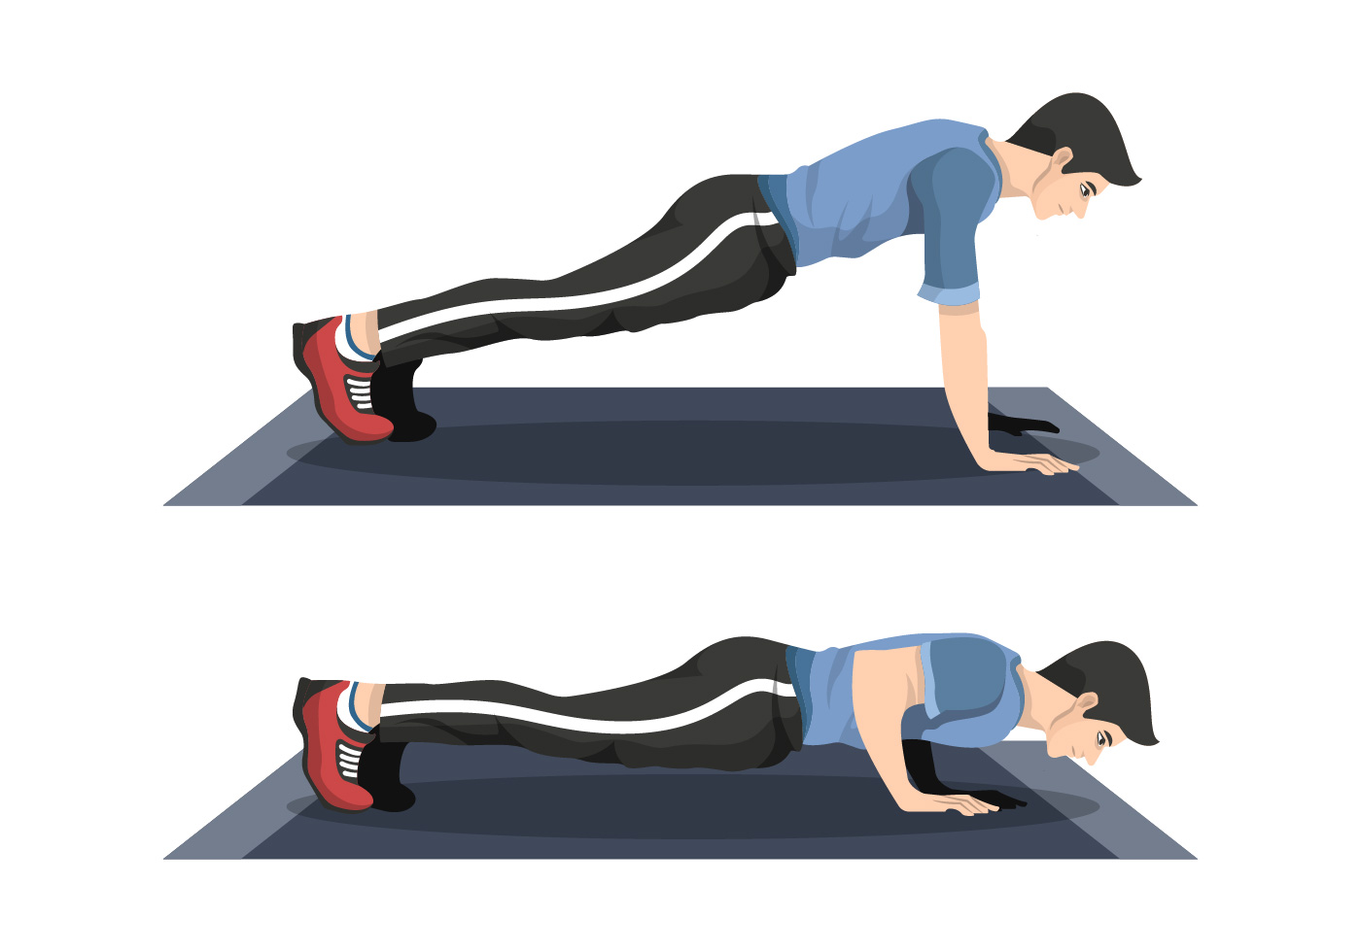
Exercise Ladder to 10

1 Star jump
2 Crunches
3 Push ups
4 Supermans
5 Hip bridges
6 Shoulder presses
7 Calf raises
8 Side leg raises (8 each side)
9 Jumping jacks
10 Squats

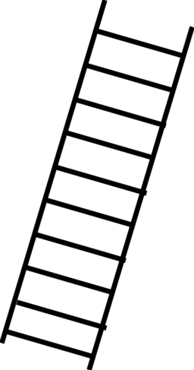

Exercise Ladder from 10

10 Lying leg raises
9 Hip bridges
8 Kicks (8 each side)
7 Bicep curls
6 Shoulder taps (6 each side)
5 Arm circles (5 forward & 5 backward)
4 Skaters (4 each side)
3 Jump ropes in place
2 Squat jumps
1 Burpee

SCAVENGER HUNT

What to do:
Get outside and go for a walk. Look high, look low, and look all around to find the following items. Each item you find corresponds with an exercise. Good luck and have fun!

Find a green, orange, or yellow leaf | 4 Push ups
Find a fire hydrant | 8 Squats
Find something that flies in the sky | 5 Star jumps
Find something that smells good | 6 Arm circles forwards
Find something that is red | 10 High knee marches
Find a pinecone or acorn | 6 Arm circles backward
Find something that walks on four legs | 5 Frog jumps
Find your shadow | 12 Jumping jacks
Find something tall | 10 Forward kicks
Find something that is pink | 12 Shoulder presses
Find a road sign | 10 Punches
Find a flag | 8 Bicep curls
Find a puddle or body of water | 12 Standing swimmers
Find the number “6” | 6 Invisible jump ropes
Find something unique | 10 of YOUR choice

EXERCISE CARD GAME
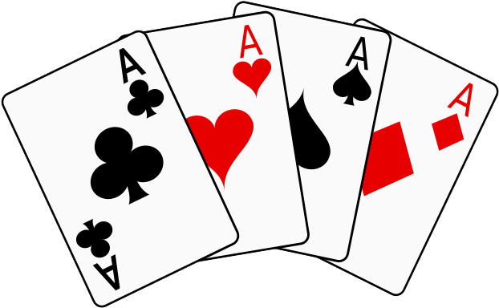
How to play:
You will need 1 shuffled deck of cards. Lay the cards face down and spread them out on the floor. Pick a card, flip it over, and complete the corresponding exercise. The number on the card represents how many reps you will do of the exercise.

King = 10 repetitions
Queen = 15 repetitions
Ace = 20 repetitions
Joker = YOUR CHOICE of exercise and repetitions

Club: Squat

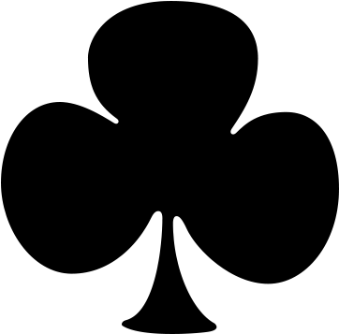

Heart: Push Up

Diamond: Crunch

Spade: Jumping Jack

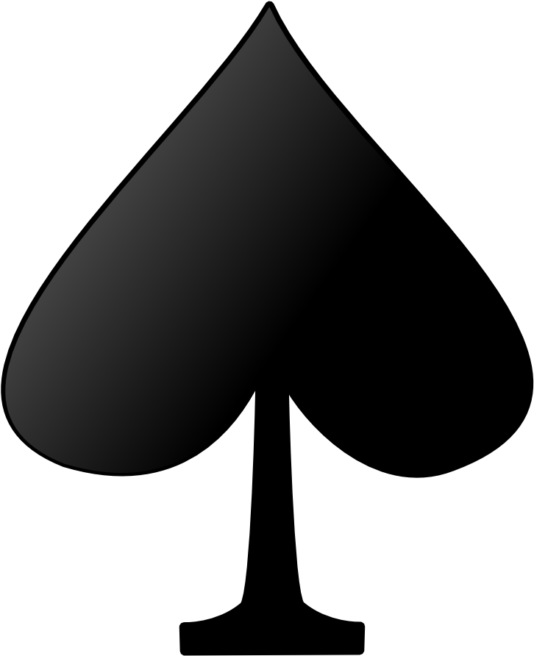

FIT DICE GAME

How to play:
You will need two dice for this activity. Start by rolling the two dice and add the numbers together. The number you got will correspond to the exercise you will do. You will then roll the two dice again, adding up the numbers to see how many repetitions you will do of the exercise.

If you rolled a…. | Then you’ll do this exercise
2 | Jumping Jacks
3 | Push Ups
4 | Squats
5 | Sit Ups
6 | Supermans
7 | Shoulder Presses
8 | Calf Raises
9 | Hip Bridges
10 | Bicep Curls
11 | Skaters
12 | YOUR CHOICE

Example:
- If I roll a 4 and a 2, I will add those numbers up to get 6
- The number 6 corresponds to the exercise supermans
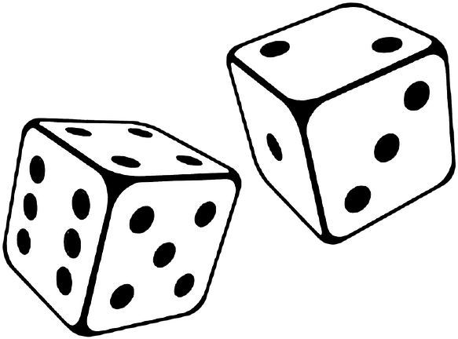
- I will then roll the dice again. If I get a 6 and a 1, the number of repetitions I will do is 7
- So, I will do 7 supermans

SPELL IT OUT

What to do:
Each letter represents an exercise with a set number of repetitions. You will think of a name, phrase, or thing and “Spell It Out”.

A - 10 arm circles | N - 10 side leg raises
B - 8 bicep curls | O - 6 shoulder taps
C - 7 squats | P - 12 high knee marches
D - 2 star jumps | Q - 8 mountain climbers
E - YOUR CHOICE | R - 3 tuck jumps
F - 5 frog jumps | S - YOUR CHOICE
G - 12 Invisible jump ropes | T - 8 lying leg raises
H - 3 supermans | U - 6 walking lunges
I - 6 hip bridges | V - 5 push ups
J - 12 jumping jacks | W - 10 kicks
K - 9 shoulder presses | X - 9 crunches
L - 8 calf raises | Y - YOUR CHOICE
M - 5 toe touch crunches | Z - 10 punches

Try spelling out:
- Your first and last name
- We Are Penn State, Go Nittany Lions
- Make up your phrase to spell out!
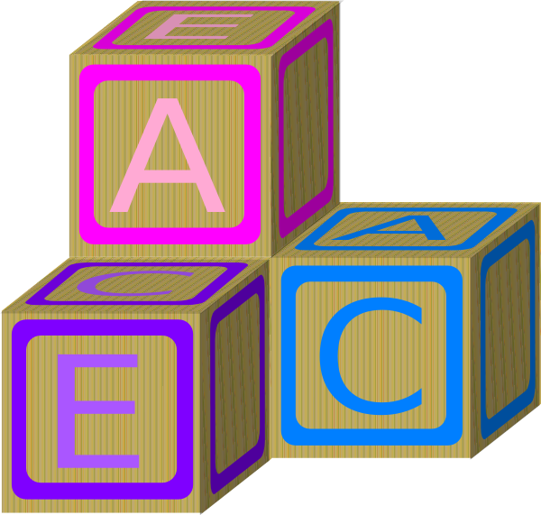

- Challenge: spell out the whole alphabet

THINGS TO USE IN YOUR HOUSE FOR A WORKOUT

So many objects can be used to add to a workout to make it more challenging or more fun! Try using some of these objects to complete your workout:
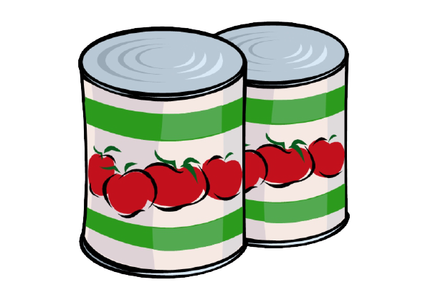

- Soup cans
  - Can be used as weights or in place of dumbbells
- A chair or your couch
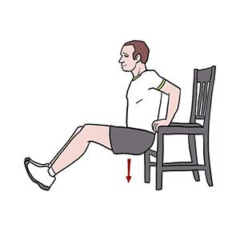
  - Can be used for exercises such as squats and tricep dips
- Water bottles
  - Can be used as weights or in place of dumbbells
- Pillows
  - Can be used to help work on your balance
  - Try standing on the the pillow with 1 leg
- Hand towels
  - Can be used as a slider
- Backpack
  - Can be used as a weight
- Beach towel
  - Can be used as a yoga mat
- Any kind of ball (basketball, soccer ball, etc.)
  - Great to use for an added challenge for a russian twist or passing to yourself in a plank
- Stairs
  - An awesome way to work your leg muscles
- Paper plates
  - Can be used as a slider
- A wall
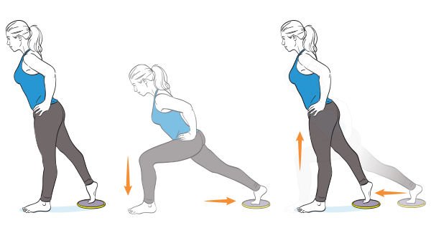
  - Great to use for exercises such as a wall sit

BUILD YOUR OWN WORKOUT

Instructions:
Choose exercises from the list and fill in the blanks.

Legs  - Squat  - Lunge  - Hip bridge  - Side leg raise  - Squat jump  - Calf raise  - Side lunge | Arms & Shoulders  - Push up  - Shoulder press  - Punches  - Arm circles  - Shoulder taps  - Bicep curls | Back  - Superman  - Bent over row  - Good morning  - Reverse snow angel
Core  - Crunches  - Lemon squeezers  - Lying leg raise  - Russian twist  - Plank  - Dead bug | Cardio  - Skaters  - Jumping jacks  - Invisible jump rope  - Run in place  - Star jumps  - Burpee  - Mountain climbers | Flexibility  - Cat & Cow  - Downward dog  - Toe touch  - Butterfly  - Back scratchers  - Arm hug

Cardio: Complete _______________ for 1 minute.

Arms & Shoulders: Complete _______________ for 15 reps.
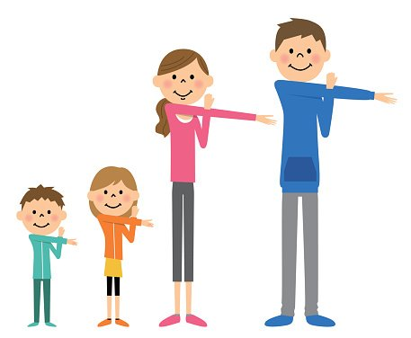
Legs: Complete _______________ for 20 reps.

Back: Complete _______________ for 12 reps.

Core: Complete _______________ for 20 reps.

Flexibility: Hold _______________ for 30 seconds.

***Repeat 3 more times using different exercises for each round!
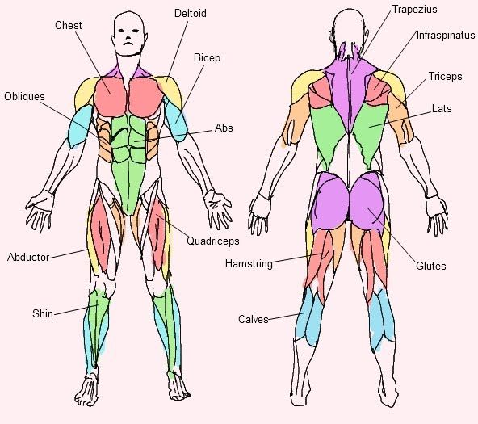
MUSCLE ANATOMY

Try these exercises that correspond to each muscle on the chart:

Deltoid  - Front arm raise | Chest  - Push up | Obliques  - Side crunch | Bicep  - Bicep curl | Abs  - Sit up
Abductor  - Clamshells | Quadriceps  - Lunge | Shin  - Foot flexors | Trapezius  - Shoulder shrugs | Infraspinatus  - Tummy taps
Triceps  - Dips | Lats  - Pull over | Hamstring  - RDL | Glutes  - Hip bridge | Calves  - Calf raise
HEALTHY RECIPES

Apple Donuts

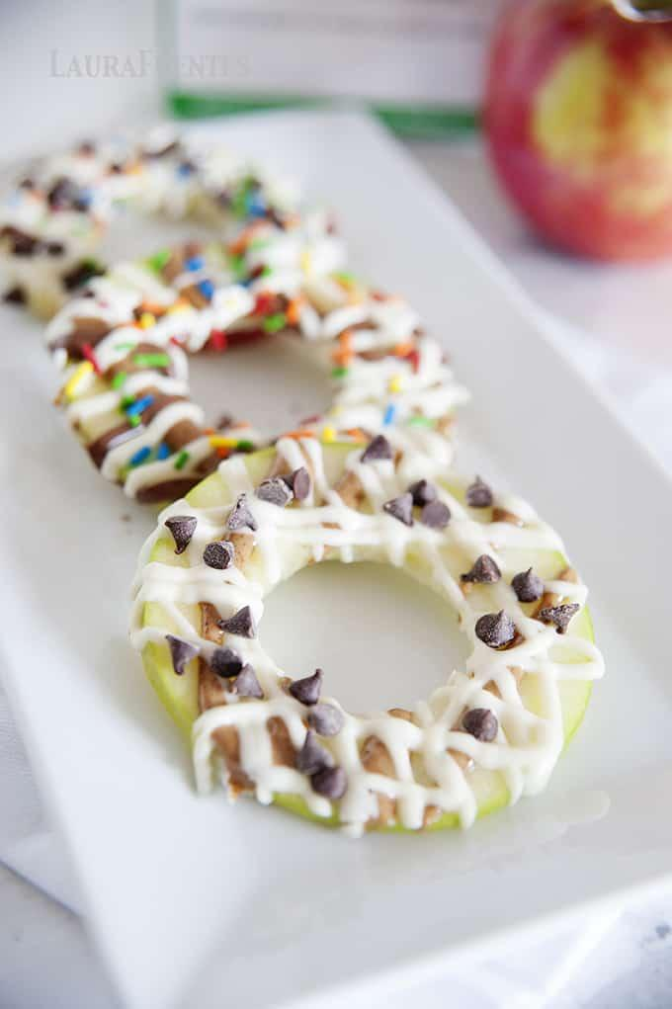
Ingredients:
- 1-2 washed apples
- Melted milk chocolate
- Peanut butter (or your favorite nut butter)
- Vanilla greek yogurt
- Shredded coconut
- Mini chocolate chips
- Granola
- Raisins
- Cinnamon
- Sprinkles

Directions:
- Cut apple slices into ⅓ inch thick slices and remove core
- Place apple slices on a plate or wax paper
- Spread peanut butter, melted chocolate, or vanilla greek yogurt on top of the apple slices
- Top with your choice of shredded coconut, mini chocolate chips, granola, raisins, cinnamon, and sprinkles
- Enjoy!

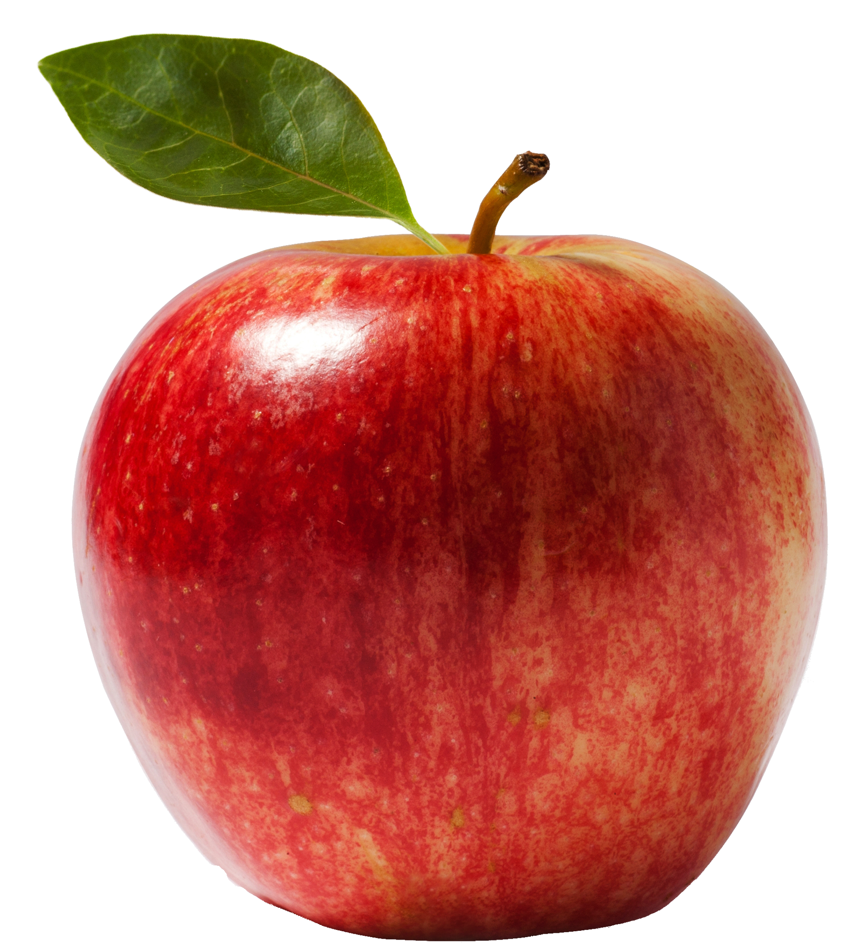

Yogurt and Berry Popsicles

Ingredients:
- 2 cups of blueberries
- 2 cups of strawberries
- 2 cups of blackberries
- 2 cups of raspberries
- 2 cups of vanilla greek yogurt
- 2 tablespoons of honey

Directions:
- Blend your choice of berry in a blender or food processor on high speed until a thick liquid consistency
- Pour the berry mix into a large bowl. Stir in the honey. Add the yogurt and gently mix everything together
- Pour the mixture into a popsicle mold
- Freeze for 2 hours and place a wooden stick into the middle of the popsicle mold
- Freeze for an additional 4-6 hours or overnight
- Run the popsicle mold under hot water for easy removal
- Enjoy!

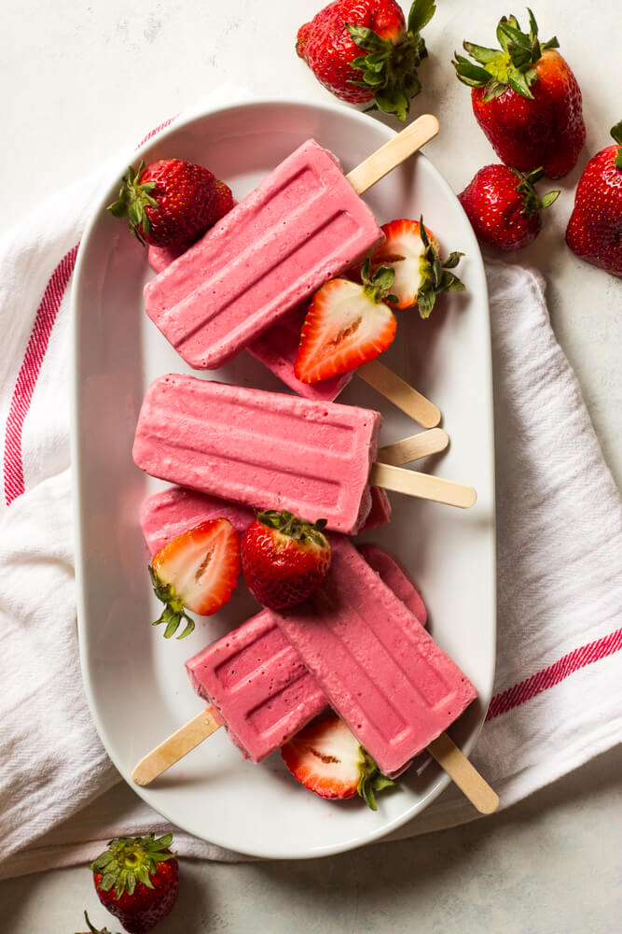
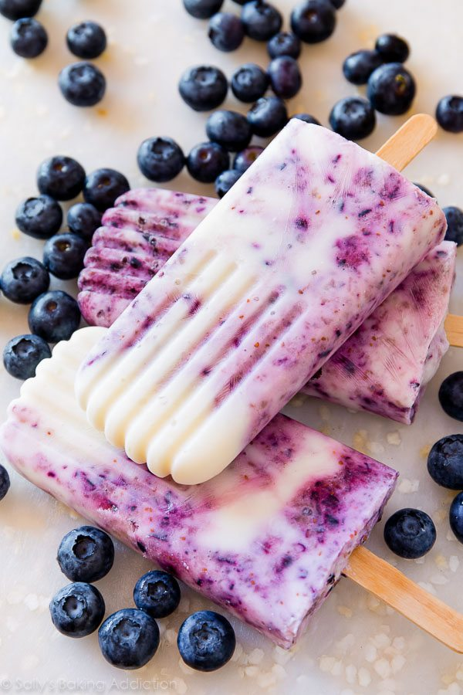

No Bake Chocolate Chip Energy Balls

Ingredients:
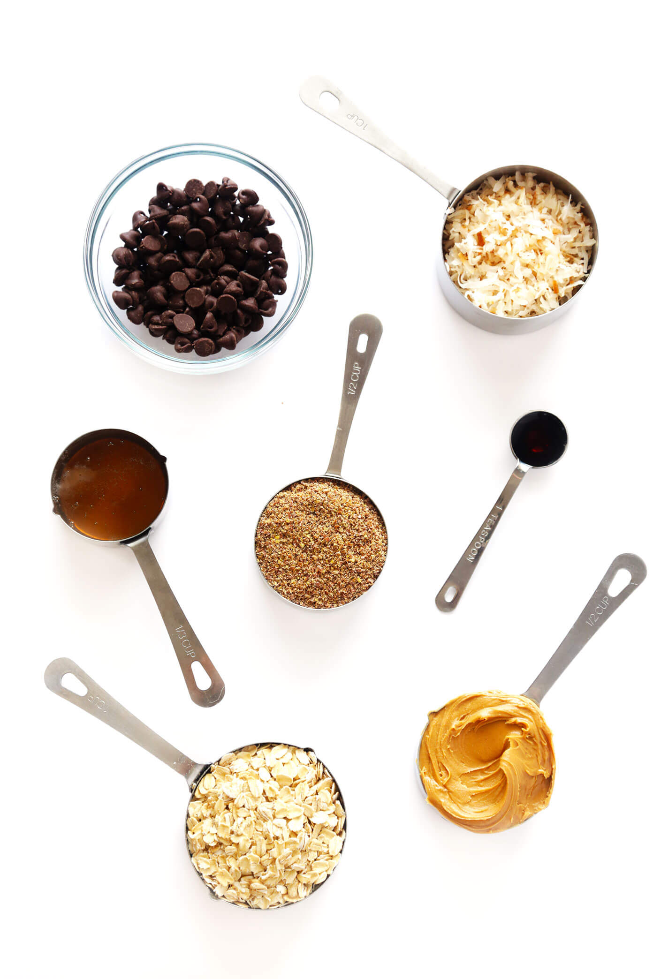
- 1 cup of old fashioned oats
- ⅔ cup of toasted shredded coconut (sweetened or unsweetened)
- ½ cup of creamy peanut butter (or your favorite nut butter)
- ½ cup of ground flaxseed
- ½ cup of semisweet chocolate chips
- ⅓ cup of honey
- 1 teaspoon of vanilla
- 1 tablespoon of chia seeds (optional)

Directions:
- Stir all ingredients together in a large mixing bowl until all ingredients are thoroughly combined
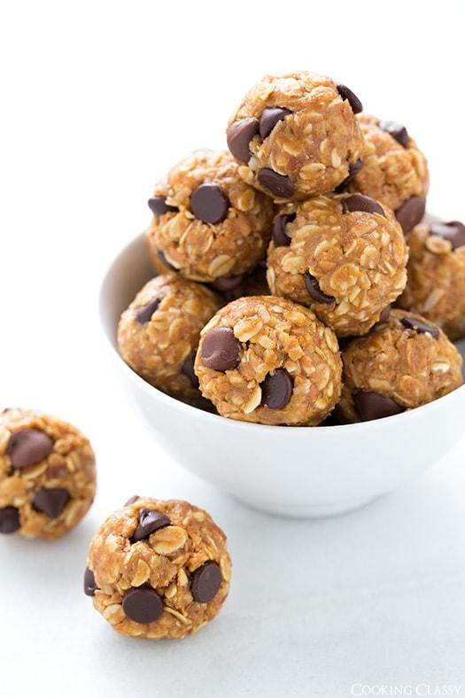
- Cover the mixing bowl and chill in the refrigerator for 1-2 hours
- Roll the mixture into 1 inch balls
- Enjoy!

Chex Trail Mix

Ingredients:
- 2 cups of chocolate Chex cereal
- 2 cups of rice Chex cereal
- 1 cup of raisins
- 1 cup of M&Ms
- 1 cup of cocktail peanuts
- 1 cup of roasted salted almonds
- ½ cup of milk chocolate chips

Directions:
- In a large bowl, combine all ingredients and mix well
- Enjoy!

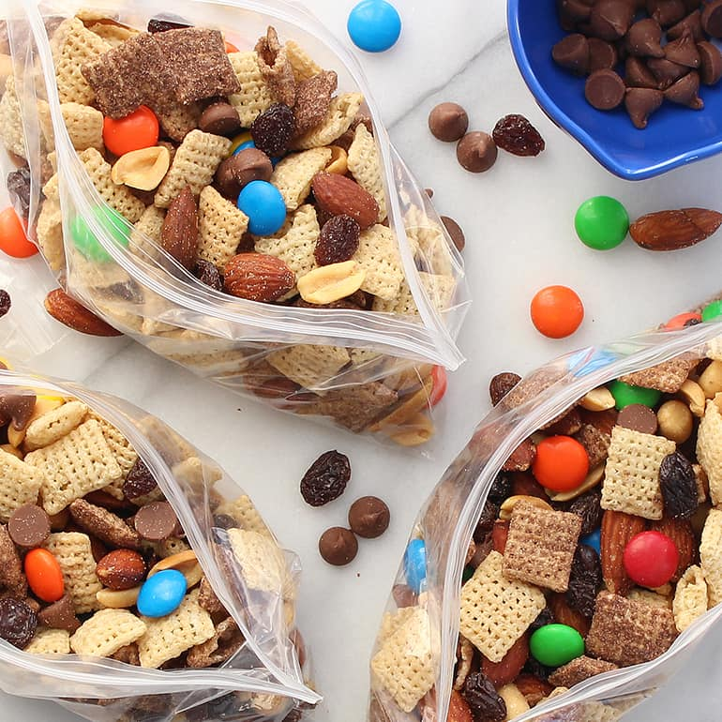

PLACES TO BE ACTIVE IN STATE COLLEGE, PA

Tusseyview Park
- Basketball court
- Tennis court
- Playground
- Drinking water fountains
- Restrooms

Holmes - Foster Park
- Basketball court
- Bocce court
- Horseshoe pits
- Playground
- Drinking water fountains
- Restrooms

Orchard park
- Softball field
- Basketball court
- Soccer field
- Tennis court
- Playground
- Walking path
- Drinking water fountains
- Restrooms

Harvest Fields DGC
- 18 hole outdoor disc golf course

Mount Nittany
- Hike a trail to the top of the mountain
- Blue trail: 4.6 miles to the top
- White trail: 3.5 miles to the top

